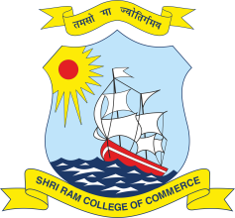 | SHRI RAM COLLEGE OF COMMERCE  University of Delhi, Maurice Nagar, Delhi – 110 007  Website: www.srcc.edu Phone: 27667905, 27666519  Email id: princialoffice@srcc.du.ac.in

NOTICE

"KNOWING YOUR APTITUDE CAN HELP YOU CHOOSE A CAREER "
We are delighted to facilitate an Online Career Assessment Test ‘INSIGHT’, being jointly organized from the Desk of Dean Delhi University with GUS Global Services. The Online test will be FREE for SRCC Second and Third year students only. The Aptitude Test will help students to assess their aptitude, interest, personality, orientation style and emotional quotient.

Registration Date for the Test: 22nd January and 23rd January' 2022 Till 11.59 pm
Online Test Date: 24th January and 25th January' 2022 till 11.59 pm
Result of the Test: Confidential and to be individually emailed to the Candidate

The Interested students should register (FREE) at https://forms.office.com/r/YFzHBM4H2B
The Result cum Analysis Report includes a 30 pages detailed report, unique Individual Development Plan on various parameters and 1-page summary report.
HURRY UP!! MAKE THE DECISION NOW

(Dr.Vandana Jain)

